**LAB-1**

**Objective:** The student will start making use of DDL commands.

**Course Outcome CO1:** Students will be able to use DDL – create/alter table statement – to create relations along with the constraints specified.

**Blooms Taxonomy Level**: BT2, BT3

1. Client (clno char(3), clname varchar(30), cladd varchar(40))

* PRIMARY KEY- clno
* clname can not be left blank

Sol:-

show databases;

create database lab1;

use lab1;

create table client(clno char(3) PRIMARY KEY, clname varchar(30) NOT NULL, cladd varchar(40));

desc client;

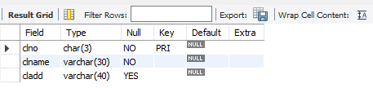

1. Project (pno char(3), pname varchar(30), pstdate date, clno char(3))

* PRIMARY KEY- pno
* FOREIGN KEY – clno refers to Client relation
* pname can not be left blank

Sol:-

show databases;

create database lab1;

use lab1;

create table client(clno char(3) PRIMARY KEY, clname varchar(30) NOT NULL, cladd varchar(40));

desc client;

create table project (pno char(3) PRIMARY KEY, pname varchar(30) NOT NULL, pstdate date, clno char(3), FOREIGN KEY(clno) REFERENCES client(clno));

desc project;

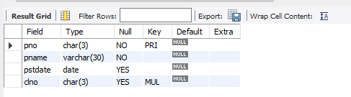

1. Department (dno char(3), dname varchar(20), dloc varchar(20), dhead char(3))

* PRIMARY KEY – dno
* FOREIGN KEY – dhead refers to eno of Employee relation
* dname can not be left blank
* default dloc is delhi

Sol:-

show databases;

create database lab1;

use lab1;

create table Client(clno char(3) PRIMARY KEY, clname varchar(30) NOT NULL, cladd varchar(40));

desc Client;

create table Project (pno char(3) PRIMARY KEY, pname varchar(30) NOT NULL, pstdate date, clno char(3), FOREIGN KEY(clno) REFERENCES client(clno));

desc Project;

create table employee(eno char(3), ename varchar(20) NOT NULL);

desc employee;

